 | SWBAT explain how plants respond to external stimuli to enhance survival in an environment.
Step 1 - Your job is to create a Pinterest page which shows what you know about how plants respond to stimuli. Be sure to include the following information
- Types of tropism - definitions and visuals of each (4 pins)
- Positive and negative tropism (2 pins)
- Dormancy (1 pin)
- Auxin - What is it and explain some real life applications (1 pin)
- MythBusters - Do plants respond to sound? If so, create a name for this type of tropism (1 pin)
 | Step 2 – Watch these two video to see what Pinterest is all about and how Pinterest works.
TROPISM | STEP 3 - RESOURCES
 | Tropism Video #1 | Tropism Video #2 | Tropism CK12 Flexbook
 | Tropism Blog | Tropism PowerPoint Presentation | Tropism Website
 | Dormancy Definition from Academic Kids Encyclopedia | Dormancy Article | Auxin from BBC’s Bitesize Site
 | Step 4 – Watch the MythBusters episode and determine if plants respond to sound. If so, create a fitting name for this type of tropism.
 | Step 5 – Talk with your shoulder partner about the key points learned from the material and update your note guide, if necessary.
Coaching Points | 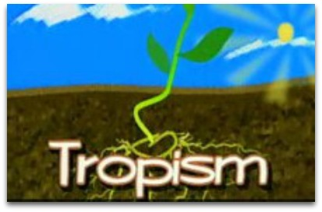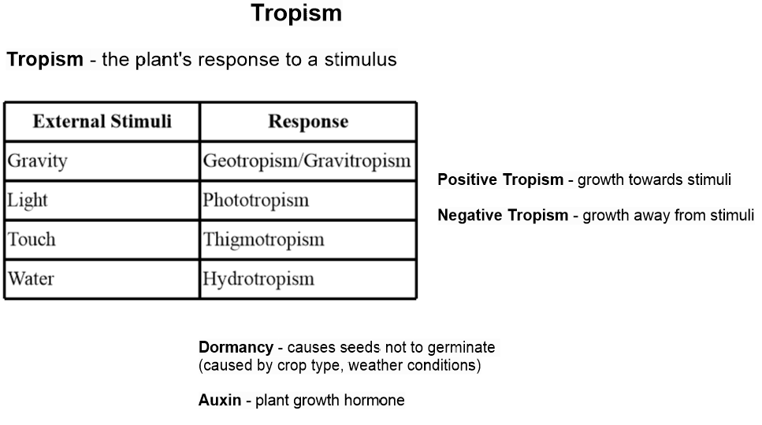

Quiz Preparations

QUIZ | Step 1 – Read over the selected study guide multiple times. | Step 2 – Using Rally Tennis, spend another 10 minutes summarizing key points about the unit. | Step 3 – Play Quizizz in class and try to score 80% or better. Your teacher will provide you with the class code. | Step 4 - Take your quiz and post your answers to Edmodo. Your teacher will provide you with directions for credit recovery if you score below an 80%.

